THE CORONADO THUNDERBIRD
BAND BOOSTER ASSOCIATION

2018-2019
Handbook

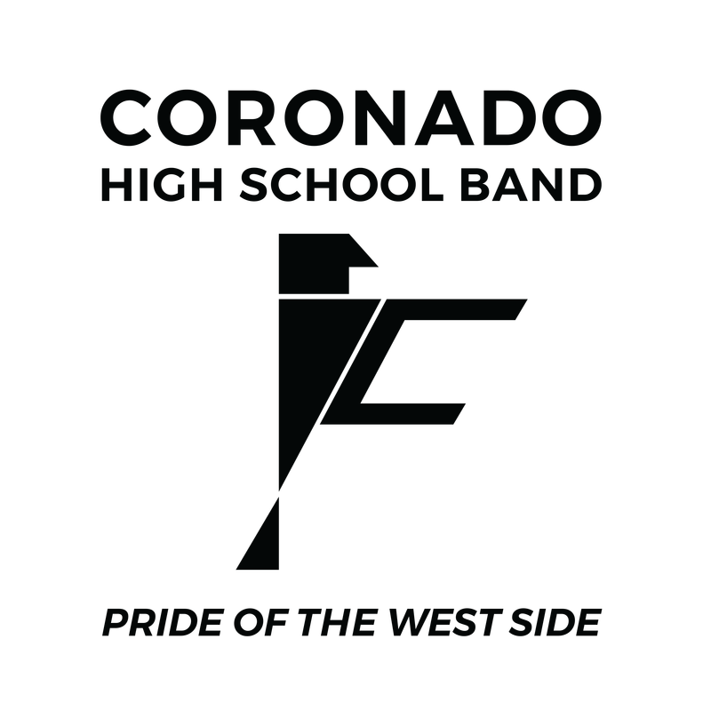

Hello T-BIRD Band Family!

Welcome
As your 2018-2019 Band Booster President, I welcome you all to the Coronado Band Booster family. Here you will find enthusiastic, new and advancing dedicated band parents who have the same goal in mind….to be there to support their children and band. So don’t be shy, Get Involved.
The Coronado Thunderbird Band has a long tradition of being an Outstanding Music program. This success is the result of the hard work of countless hours given by its Directors, students and parents working together.
The purpose of the Coronado Thunderbird Band Booster Association is to provide financial
Assistance (contributions, fundraising, sponsorships, etc.) and other assistance (volunteer support
On various committees) to the Coronado Band. As a parent or guardian of a band student, after
filling out a Band Booster Membership Registration Form, you too, are a member of the Coronado
Thunderbird Band Boosters Association! Our responsibilities are many, but with the combined
talents and efforts of everyone, there is no task that we cannot accomplish. The students and
Directors do their part. As parents let’s show OUR support of the T-Bird Band. Lend a hand and be
a part of your child’s band experience and the great tradition that IS the Coronado Thunderbird
Band.

It will change not only your student’s life, but yours as well!

Joann Garcia
2018-2019 Band Booster President

2018-2019 Band Booster Board:
Joann Garcia – President
Irene Delgado – Aide to the President
Donna Leffman - Treasurer
Teri Rosen - Assistant Treasurer
Laura Judge- Secretary
Lily and David Salas/Noel Saldanha- Vice President of Equipment
Jana Phillips–Vice President of Support
Judith Baca – Co VP Support
Andy Werner – Cash Management
Maggie Portillo–Vice President Ways and Means of Fundraising
JoAnn Fontanez – Vice President of Guard
Lucy Ruiz – Vice President Outreach
Yolie Lozoya - Parliamentarian

Frequently Asked Questions

Who are the band boosters?
Our parent-led booster organization is a 501c3 tax-exempt non-profit organization.
Participation in the Band Booster Association (BBA) is voluntary and is not a requirement for your child
to be a member of the Coronado band program. All parents/guardians are requested and
encouraged to participate. The booster organization’s mission is to enhance the overall
experience for every band student. The boosters help the band with just about everything,
including meals, uniforms, equipment, water, etc. The list goes on and on.
Every parent can find a way to help that works best with their schedule. We hope EACH of you makes an effort to get involved. It is hard work but it is for our students, and everyone has fun in the process.

What meetings do I have to go to?
Booster meetings are very important and provide a variety of information that will help you stay
informed and involved. Critical meetings are held in August and October, and cover important
topics such as scheduling, marching season needs, and upcoming fundraisers. The BBA provides
a list of all scheduled meetings on the website and in your emails.
What is my student’s “Fair Share Amount” and contribution schedule?
The booster board and the directors have worked very hard to put together this year’s BBA budget.
In order to meet the BBA projected budget of $99,420 for the school year, we are asking each student total Fair Share to be $450.for the first child, and $375 for additional siblings. This amount does not include $60.00 for required contest meals distributed to each child by our booster meal parents. Additionally, the Band Booster Association has committed to help raise additional funds through general fundraisers to meet the band’s total budget needs.
The following generally summarizes your student’s My Fair Share Amount:

ADMIN, HOSPITALITY & PROF DEVELOPMENT 5%
EQUIPMENT 6%
CONTEST RELATED EXPENSES 6%
INSTRUCTION 30%
HOSPITALITY 1%
PERFORMANCE 47%
PROFESSIONAL DEVELOPMENT 5%
Total My Fair Share Amount: $450.00

Required Meals $ 60
Optional Meals $75

- Includes contest entry fees, buses, equipment truck rental and fuel expenses, clinicians, guard instructors, marching techs, and other instructional expense, marching and guard drill, music, props, choreography, uniform cleaning, marching and guard related equipment, equipment truck and fuel expenses to away games, and other similar expenses not covered by EPISD.

Mandatory Contest Meals (per student) – $60 Must be paid by September 1, 2018

September 29th – T- Bird Invitational
October 13th – UIL Region
October 27th – Area
EPISD
SISD

OPTIONAL MEALS (per student) - $75.00 Must be paid by August 15, 2018

(10 Meals)

August 31st
September 6th
September 14th
September 21st
September 28th
October 11th
October 18th
October 26th
November 2nd
November 9th

The recommended My Fair Share payment schedule is listed below. This schedule includes a larger first payment due to the fact that the majority of our budget expenses are incurred during the first two months of marching season.
Please remember that the boosters have committed to providing many fundraising opportunities to help offset your My Fair Share payments. . The boosters and directors encourage you and your child to participate in every fundraiser.

1st Contribution - Due August 1, 2018 $125.00
2nd Contribution - Due August 15, 2018 $ 125.00
3rd Contribution – Due September 1, 2018 $ 50.00
4th Contribution – Due September 15, 2018 $ 50.00
5th Contribution - Due October 1, 2018 $ 50.00
6th Contribution – Due October 15, 2018 $ 50.00

Total Student Contribution: $450.00

Required Contest Meals: $60.00 to be paid by September 1st
Optional Game Meals; $75 to be paid by August 15th

What if my student becomes ineligible due to grades?

Your student is still a member of the band and is encouraged to complete his or her My Fair Share

How do the boosters handle the money?

Meet the “MAILBOX “in the Band Room!

The BBA has a carefully designed system to collect money and correspondence or
communications, forms, etc., from the students. It all starts with the “Mailbox” in the band
room. The BBA uses the “Mailbox” to ensure the security of its money collections.
Here is how it works. A supply of envelopes is kept by the “Mailbox.” When turning in any
money, fundraiser proceeds, etc.,
students MUST print the following information on an envelope to insure proper credit is given to them:
- The student’s name
- Fundraising project/or reason for money;
3) The amount of money being turned in; and
4) Whether paid by cash or check and Check #. The BBA prefers checks rather than cash as checks are a good source of proof of payment.

The BBA’s money handling procedure insures all monies
reach the proper hands. Students will not lose a check nearly as easily as cash. If a student
collects cash during a fundraiser, it is strongly recommended that parents take the cash
and write a personal check payable to “CTBBA” to be deposited into the “Mailbox” in a
properly completed envelope, as described above.

What is the address for the Booster Association?

The Coronado Thunderbird Band Booster Association
P.O. Box 13414
El Paso, TX 79913
DO NOT USE THE SCHOOL ADDRESS for Band Booster business!!

CORONADO THUNDERBIRD BAND BOOSTER ASSOCIATION COMMITMENT

I/we acknowledge that I/we have reviewed the Coronado Thunderbird Band Booster Association
2018-2019 Handbook and are aware of the fundraising contribution.

____ Check Here if you need help meeting your fundraising fair share.

____ Check Here if you can help sponsor another band student with an addition donation

I/we have also reviewed the pregame meal procedures and understand I/we must let the Band
Booster Association know of any dietary needs our student may have.

Please list out any dietary considerations we must take into account for your student.

__________________________________________________________________

Parent’s/Guardian’s Printed Name ____________________________________

Parent’s/Guardian’s Signature _______________________ Date ____________

Parent’s/Guardian’s Printed Name ____________________________________

Parent’s/Guardian’s Signature _______________________ Date ________

